Multiple hierarchy

Exercise #2

Flutter Developer Boot-camp

# **Purpose**

This exercise demonstrates how to practice and understand the concepts of class definitions, object-oriented programming, and method interactions in Dart. Specifically

**Problem**

This exercise introduces fundamental concepts of object-oriented programming. It defines classes A, B, C, D, and F, each holding a string variable initialized with specific values except A. Class A includes a method printValues that prints these values from instances of B, C, D, and F. Through instantiation in main, the code demonstrates how objects interact, highlighting encapsulation and modular design principles in object-oriented programming.

**How to Solve**

1. Checkout the Exercise from Git Repo:

git clone -b <user-branch> <repo-URL>

2. Open the root folder inside VS Code

3. Open the root folder in terminal

4. Run the command dart run filename.dart

5. Create Classes and Variables:

* A: Contains printValues method to print values from other classes.
* B, C, D, F: Each has a string variable (bValue, cValue, dValue, fValue) with specific values.

6. Main Function:

* Creates instances of A, B, C, D, and F.
* Calls printValues method of A to print values from instances of B, C, D, and F.

7. Method printValues in Class A:

* Receives parameters (b, c, d, f) representing instances of B, C, D, and F.
* Prints values of bValue, cValue, dValue, and fValue from these instances.

8. Output: Displays:

* Value from class B: Value from B
* Value from class C: Value from C
* Value from class D: Value from D
* Value from class F: Value from F

9. Go To File: <specific-file-with---method> à <method-name>, implement your logic.

**You will Achieve**

When you complete this exercise you will learn the following:

Methods and Functions Included

* **Class A:**
* Method: printValues(B b, C c, D d, F f)
* Prints values from instances of classes B, C, D, and F.
* Encapsulates functionality to display specific information stored in different objects.
* **Class B, C, D, F:**
* Variables: bValue, cValue, dValue, fValue
* String variables initialized with specific values ("Value from B", "Value from C", "Value from D", "Value from F").
* Provides distinct data points that can be accessed and used by other classes.
* **Main Function:**
* Object Creation: Instances of A, B, C, D, and F are created (A a = A();, B b = B();, etc.).
* Establishes objects that interact according to the defined classes and methods.
* Sets up the environment to demonstrate interaction and data flow between objects.

# **Screenshots**

## **Expected output (Multiple hierarchy)**

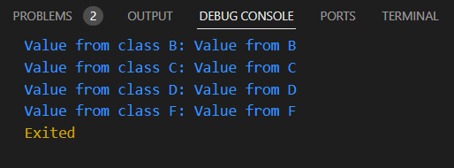

# **How to submit your exercise**

Push your project back to the same git branch using command:

<command name>

# **Happy Coding!**